Recipe: Namu Gaji’s Kimchi Fried Rice

[Janelle Bitker](https://www.sfchronicle.com/author/janelle-bitker/)Dec. 31, 2019

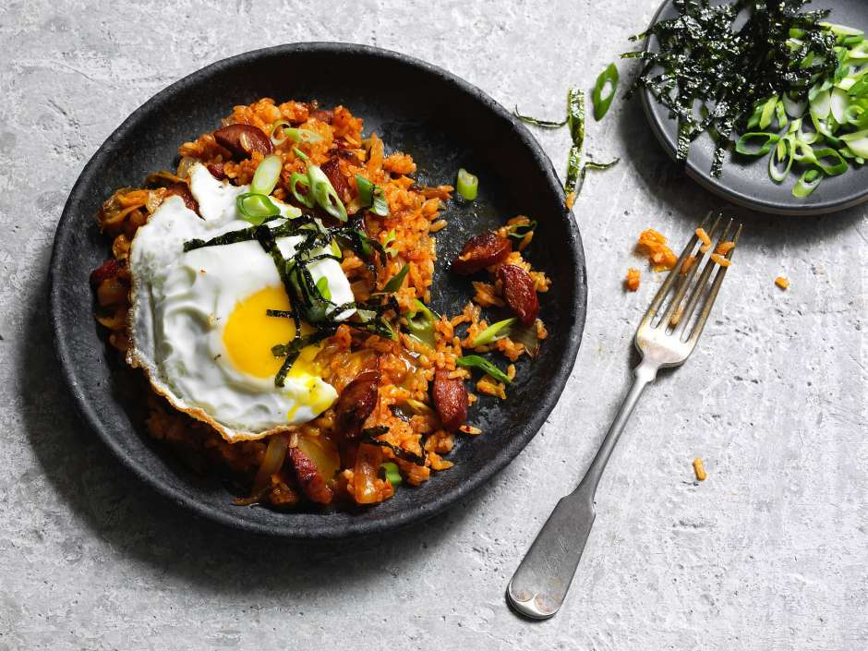

Korean food [is booming](https://www.sfchronicle.com/restaurants/article/Is-San-Francisco-ready-for-a-Korean-food-boom-14287663.php?psid=isrZz) across the Bay Area, but Namu Gaji, one of the pioneers of contemporary, California-inflected Korean food in San Francisco, is currently closed.

The Mission restaurant on the edge of Dolores Park shut down last year for mandatory seismic retrofitting. Months later, owners and brothers Dennis, Daniel and David Lee [announced they’d move Namu Gaji](https://www.sfchronicle.com/food/article/Big-changes-for-Namu-crew-Namu-Gaji-moves-to-14079447.php) to a new spot in SoMa, but the new Namu Gaji has yet to open. Instead, they’ve focused on expanding Namu Stonepot, a more casual restaurant with a pared-down menu.

That is all to say that you might be missing Namu Gaji’s Kimchi Fried Rice, and this recipe can help.

While the hot dogs and bacon make this dish extra fun, salty and delicious, you could easily leave them out for a vegetarian version. The tangy kimchi and gochujang (Korean fermented chile paste) pack plenty of flavor on their own.

**Namu Gaji’s Kimchi Fried Rice**

**Serves 6 as a side dish or appetizer**

The next time you’re cooking rice, plan ahead and add a few more cups. That way, you’ll already have rice languishing in your fridge when you want to make this Kimchi Fried Rice, and it’ll come together in minutes.

**½** cup unsalted butter

**2** hot dogs, halved lengthwise and thinly sliced crosswise (1 to 1¼ cup)

**5** bacon strips, thinly sliced crosswise (about 1 cup)

**1** large yellow onion, thinly sliced

**4** cups cooked and cooled rice (preferably Koshihikari brand, but long-grain is fine)

**1** teaspoon fine sea salt

**1** tablespoon toasted sesame oil

**4** cups napa cabbage kimchi, sliced

**¼** cup gochujang (Korean chile sauce) or 2 tablespoons Sriracha

**4** teaspoons extra-virgin olive oil, divided

**4** large eggs

**1** green scallion top, thinly sliced

**1** tablespoon kizami (shredded) nori (optional)

**Instructions:** In a wok or a large skillet set over medium-high heat, add the butter, hot dogs, bacon and onion, and cook, stirring occasionally, until the onions are translucent, 4 to 6 minutes. Mix in the rice and salt, then add the sesame oil and cook for another minute without stirring. Continue to cook, until the rice is slightly browned and heated through, 6 to 8 minutes.

Add the kimchi and stir until incorporated. Add the gochujang and cook until the rice starts to caramelize and stick to the bottom of the pan, 1 to 2 minutes. Turn off the heat and divide the rice among 4 bowls. Keep warm.

In a skillet set over medium heat, carefully fry the eggs with 1 teaspoon of olive oil per egg, until the whites are set and the yolks are still runny, about 1½ to 2 minutes. Use a spatula to transfer them to the bowls of rice. Sprinkle some scallions and nori, if using, over each bowl and serve.

<https://www.sfchronicle.com/recipes/article/Recipe-Namu-Gaji-s-Kimchi-Fried-Rice-14941748.php>